CPE301 – SPRING 2019

Design Assignment 2C

Student Name: Carlos D Zuniga

Student #: 2000783713

Student Email: zunigc2@unlv.nevada.edu

Primary Github address: https://github.com/cdaniel64/blassen/

Directory: DA2/DA2C

1. **COMPONENTS LIST AND CONNECTION BLOCK DIAGRAM w/ PINS**

List of Components used

Block diagram with pins used in the Atmega328P and HiLEGO Shield

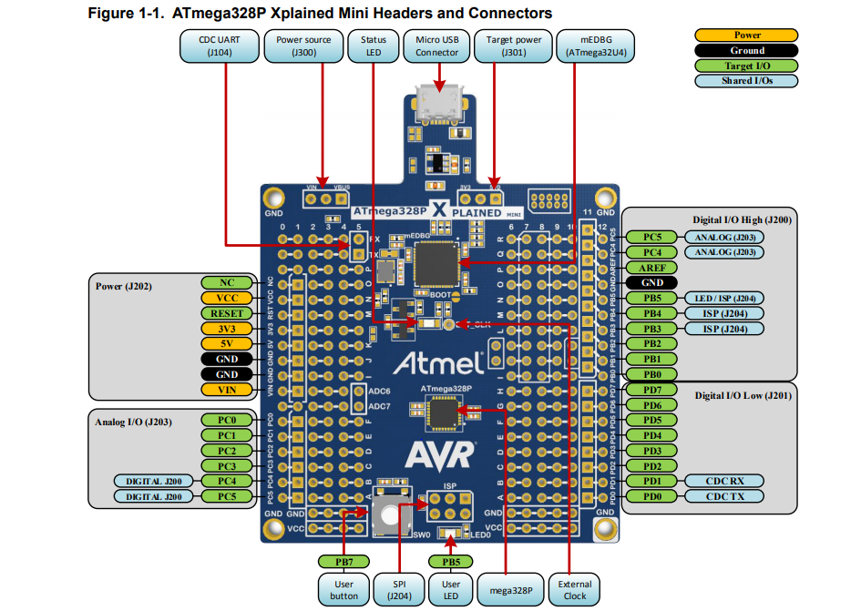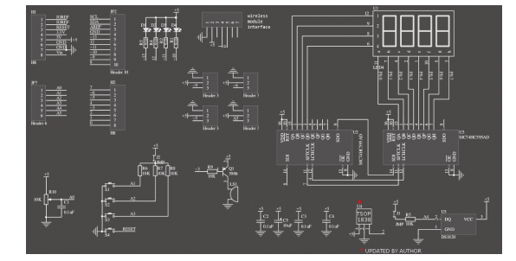

1. **INITIAL/MODIFIED/DEVELOPED CODE OF TASKS**

**Task 1 Part 1 and 2 – Normal mode**

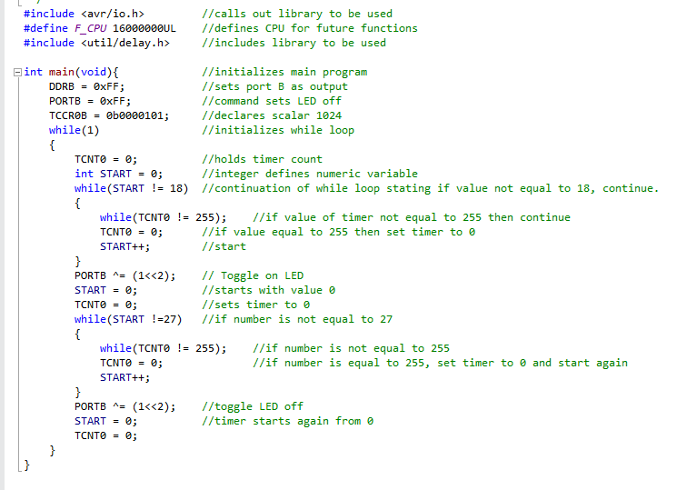

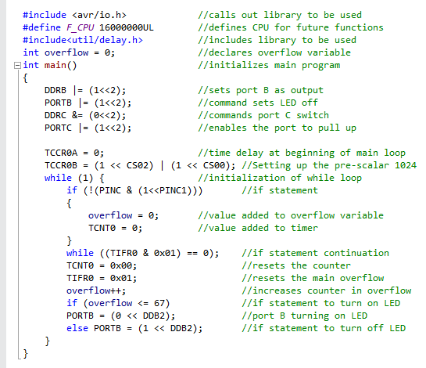

**Task 2 Part 1 and 2 – OVF**

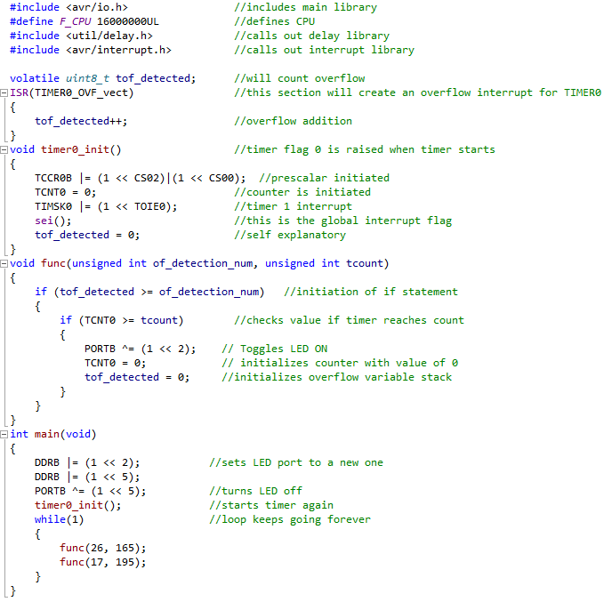

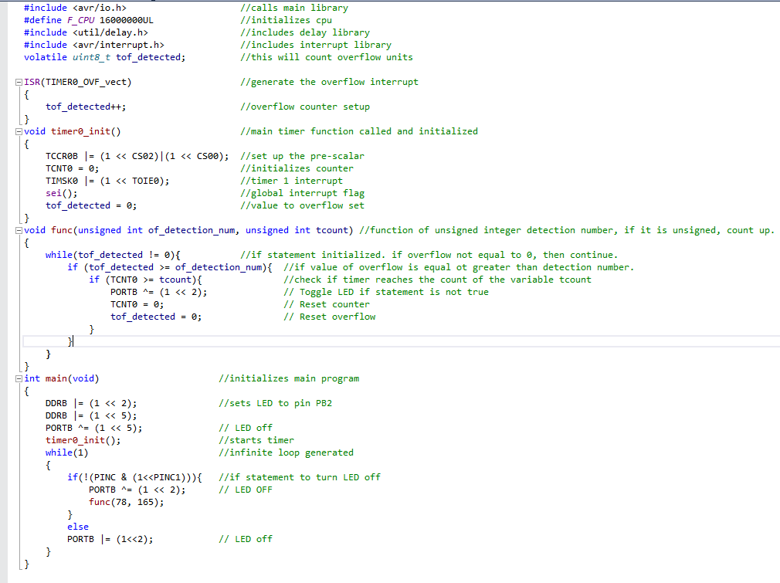

**Task 3 Part 1 and 2**

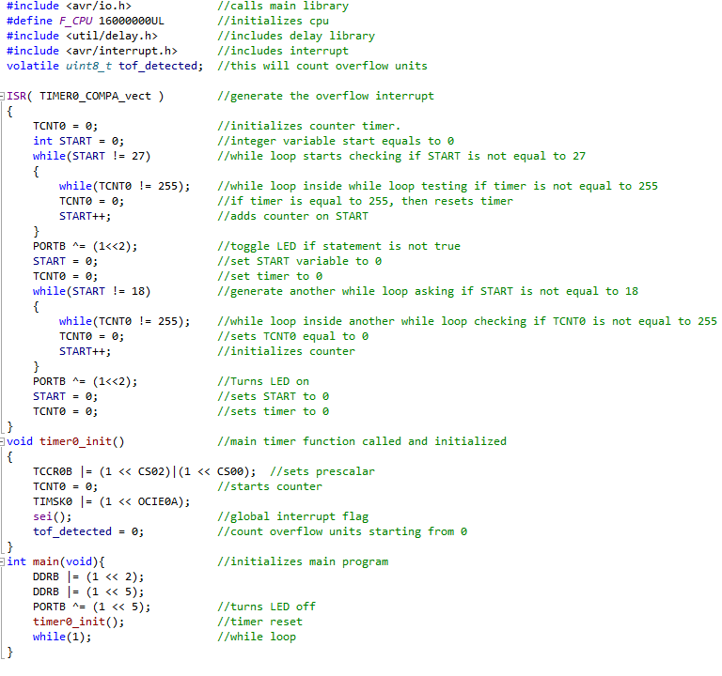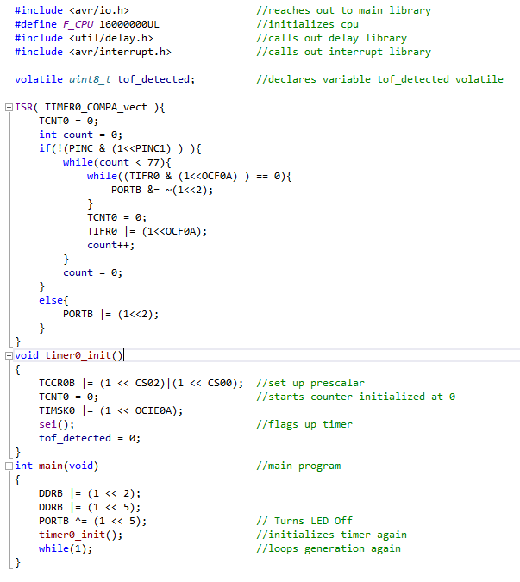

1. **SCHEMATICS**

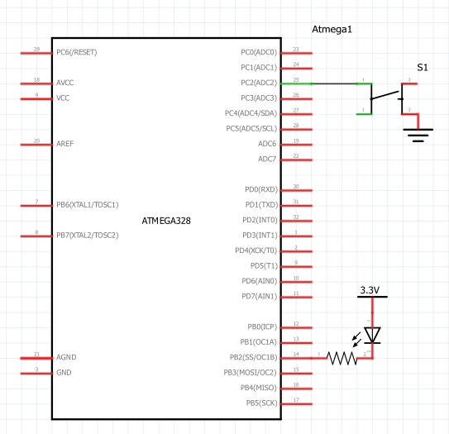

1. **SCREENSHOTS OF EACH TASK OUTPUT (ATMEL STUDIO OUTPUT)**

Task 1,2 and 3 Part 1 Clock function from logic analyzer.

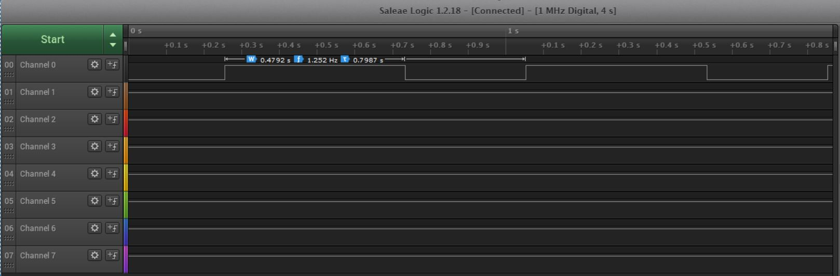

Task 1,2 and 3 Part 2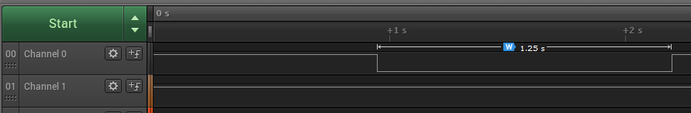

1. **VIDEO LINKS OF EACH DEMO**

<https://www.youtube.com/watch?v=-3CQGEKBCOc>

<https://www.youtube.com/watch?v=BKJk_Egrim8>

1. **GITHUB LINK OF THIS DA**

<https://github.com/cdaniel64/blassen>

**Student Academic Misconduct Policy**

<http://studentconduct.unlv.edu/misconduct/policy.html>

“This assignment submission is my own, original work”.